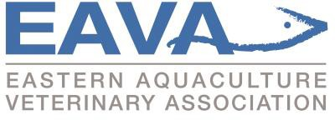

Membership Application / Renewal 2022
(2022 deadline for payment is June 30,2022)

- Full Member  - Associate Member | $100 USD/CAD  $40 USD/CAD | (veterinarians working primarily with aquatic animals)  (veterinarians not working primarily with aquatics)
- Student Member | $20 USD/CAD | (DVM or DVM graduate students)

Name: Click or tap here to enter text.

Mailing: Click or tap here to enter text.

Telephone: Business: Click or tap here to enter text.
Mobile: Click or tap here to enter text.
Fax: Click or tap here to enter text.
Home: Click or tap here to enter text.

Email: Click or tap here to enter text.

**Note: As per the EAVA by-laws, members cannot use a publicly accessible email address (ex. Government email) for EAVA communications. **

College /Year DVM/VMD obtained: /

Area of Employment: Choose an item.
Click or tap here to enter text.
Membership Category: Click or tap to enter a date.
Payment Method: Choose an item.

Member Signature: Date: Click or tap to enter a date.

For students a supervisor or faculty member must sign to confirm status:
Supervisor Signature: Date: Click or tap to enter a date.

Please make cheques payable to EAVA (with member name on the cheque).
Please save as a “.doc” or “.docs” file before sending
Electronic transfer funds are accepted through PayPal or by interac payment
Please forward application and funds to the current EAVA Treasurer (address below):

Steve Backman,
EAVA Treasurer
PO Box 3940
St. Andrews, NB, E5B 3S7
Canada

